Linux - File Structure

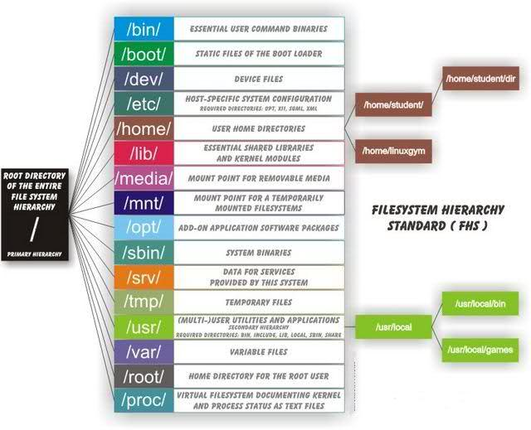

# General Structure

### /bin

All executable binary programs required during booting, repairing, running into single user mode, and other important commands (cat, ls, etc)

### /boot

Holds important files during boot-up process including the linux kernel

### /dev

Contains device files for hardward devices. For example, cpu and cdrom. When accessing a item in dev you are interacting with the indiviual bits and bytes on the hardware, to access actual files use the /media directory.

* /dev/null - pseudo device which does not exist, direct output to here to ignore and delete it

### /etc

Contains application configuration files and the startup, shutdown, start, and stop script for every induvidual program

### /home

Home directory of users. Each user has subdirectory in /home named after their username.

### /lib

Contains kernel modules and shred library images required to boot the system and run commands in the root file system

### /lost+found

Install during creation of linux and is where files which are broken during unexpected shut-downs are stored. Can be useful for recovery.

### /media

Temporary mounting for external hardware devices such as usb drives and external hard drives

### /mnt

Temporary mounting for a mounting-file-system

### /opt

Sometimes called optional, contains third party application software such as Java

### /proc

Pseudo file-system which contains information about running processes with process-id (pid)

### /root

Home directory of the root user

### /run

Only clean solution for the early-runtime-dir problem

### /sbin

Contains binary executable programs required by the sysadmin such as iptables, ifconfig, etc

### /srv

Called 'Service', contains server and service related files

### /sys

Virtual filesystem which stores information on and allows modification to devices connected to the system

### /tmp

Temporary storage available to all which is cleared on next boot

### /usr

Contains binaries, docs, source code, and libraries for second level programs (non-system programs)

### /var

Contains variable files of which the contents are expected to grow and change. For example, log, lock, spool, mail, and temp files.